Bus Passenger Occupancy Simulation
Author: Radhasahithi Challa
1. Problem Statement
Develop a Python program to simulate passenger occupancy on a bus across multiple stops. At each stop, the program records the number of passengers boarding and alighting, calculates the number of passengers remaining on the bus, and checks whether the bus exceeds its maximum seating or passenger capacity. The program displays the passenger count and capacity status at each stop.
2. Objectives
- Accept the bus's maximum passenger capacity.
- Record boarding and alighting counts at multiple stops.
- Calculate the passenger count after each stop.
- Ensure that the number of passengers never becomes negative.
- Identify and report capacity violations.
- Display a summary of passenger occupancy throughout the journey.
3. Assumptions
- The bus starts with zero passengers.
- The bus has a fixed maximum capacity.
- Passengers alight before new passengers board at each stop.
- The number of boarding and alighting passengers must be non-negative integers.
- Passengers cannot alight if they are not on the bus.
- A capacity violation occurs when passenger occupancy exceeds the maximum capacity.
- If a capacity violation occurs, the program reports it but continues the simulation using the entered counts.
- All boarding and alighting figures are assumed to be valid counts provided by the operator.
4. Algorithm
- Start the program.
- Input the bus's maximum capacity.
- Input the number of stops.
- Initialize the passenger count to zero.
- For each stop:
  - Input the number of passengers alighting.
  - Check whether the alighting count exceeds the current passenger count.
  - If invalid, display an error and request valid input.
  - Subtract alighting passengers from the current count.
  - Input the number of passengers boarding.
  - Add boarding passengers to the current count.
  - Compare the passenger count with the maximum capacity.
  - If occupancy exceeds capacity, flag a capacity violation.
  - Otherwise, display the available capacity.
- Display the final passenger count and total capacity violations.
- Stop.
5. Flowchart
START
Input bus capacity and number of stops
Initialize passenger count to zero
Input alighting count and validate it
Subtract alighting passengers; input and add boarding passengers
Is passenger count greater than capacity?
Yes
Flag capacity violation
No
Display occupancy status
Repeat for remaining stops
Display final summary
STOP
6. Pseudocode
BEGIN
INPUT bus_capacity
INPUT number_of_stops
passengers = 0
violations = 0
FOR stop FROM 1 TO number_of_stops:
INPUT alighting
WHILE alighting < 0 OR alighting > passengers:
DISPLAY "Invalid alighting count"
INPUT alighting
passengers = passengers - alighting
INPUT boarding
WHILE boarding < 0:
DISPLAY "Invalid boarding count"
INPUT boarding
passengers = passengers + boarding
IF passengers > bus_capacity:
DISPLAY "Capacity Violation"
violations = violations + 1
ELSE:
DISPLAY "Within Capacity"
DISPLAY passengers
END FOR
DISPLAY final passenger count
DISPLAY total violations

END
8. Line-by-Line Explanation
Code / statement | Explanation
capacity = int(input(...)) | Reads the maximum passenger capacity of the bus.
stops = int(input(...)) | Reads the number of stops on the route.
if capacity <= 0 or stops <= 0: | Validates the capacity and number of stops.
passengers = 0 | Initializes the bus with no passengers.
violations = 0 | Initializes the capacity violation counter.
for stop in range(1, stops + 1): | Repeats the simulation for each stop.
while True: | Repeats input until a valid value is entered.
alighting = int(input(...)) | Reads the number of passengers leaving the bus.
0 <= alighting <= passengers | Ensures passengers cannot alight beyond the current occupancy.
passengers -= alighting | Removes alighting passengers from the bus.
boarding = int(input(...)) | Reads the number of passengers entering the bus.
passengers += boarding | Adds the boarding passengers to occupancy.
if passengers > capacity: | Checks whether occupancy exceeds the limit.
violations += 1 | Counts a capacity violation at that stop.
capacity - passengers | Calculates the remaining available capacity.
print(...) | Displays stop-wise occupancy and the final summary.
9. Test Cases
Assume the bus capacity is 40 passengers.
Test | Initial passengers | Alighting | Boarding | Final passengers | Expected result
1 | 0 | 0 | 20 | 20 | Within capacity
2 | 20 | 5 | 10 | 25 | Within capacity
3 | 35 | 5 | 15 | 45 | Capacity violation; 5 over capacity
4 | 10 | 12 | — | — | Invalid alighting count; retry
5 | 15 | 5 | 0 | 10 | Within capacity
6 | 0 | 0 | 40 | 40 | At full capacity, no violation
10. Sample Output
Enter bus capacity: 40
Enter number of stops: 3

===== BUS OCCUPANCY REPORT =====

Stop 1
Number of passengers alighting: 0
Number of passengers boarding: 25
Passengers after stop: 25
Status: Within capacity
Available seats: 15

Stop 2
Number of passengers alighting: 5
Number of passengers boarding: 15
Passengers after stop: 35
Status: Within capacity
Available seats: 5

Stop 3
Number of passengers alighting: 0
Number of passengers boarding: 10
Passengers after stop: 45
Status: CAPACITY VIOLATION!
Excess passengers: 5

===== FINAL SUMMARY =====
Bus capacity: 40
Final passengers: 45
Capacity violations: 1
Overall status: Capacity violations detected

My output

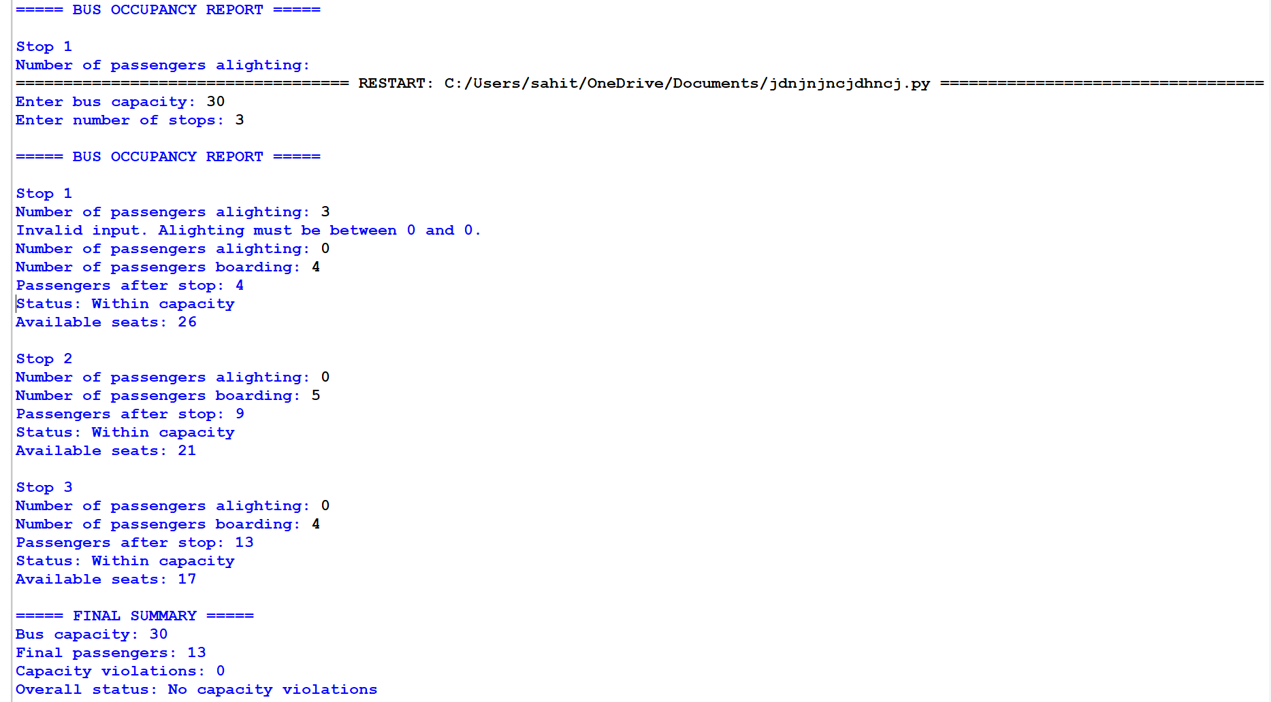
11. Conclusion
The Bus Passenger Occupancy Simulation program tracks passenger boarding and alighting across multiple stops. It calculates the current passenger count, validates alighting inputs, and detects capacity violations. This program can help demonstrate passenger flow management and capacity monitoring in public transp

